THE RELATIONSHIP BETWEEN CRIME RATES AND SOCIO-ECONOMIC FACTORS
Azene Zenebe, Bowie State University
Nega Lakew, Bowie State University
Ademola Obisesan, Bowie State University
Nitisha Ponnala, Bowie State University
Moriah Parker, Bowie State University
ABSTRACT
Socioeconomic conditions have long been acknowledged as pivotal determinants of crime trends. Established criminological theories, such as strain theory and social disorganization theory, offer a framework for understanding these dynamics. This study empirically examines the relationship between crime rates and socioeconomic factors like unemployment, household income levels, racial backgrounds, and the level of education people have using county-level crime data and socio-economic data on Maryland, USA. A quantitative analysis of county-level crime data from 2010 to 2020 was used. A descriptive analysis was used for data understanding followed by data transformation for normalization. The paper further examines the relationships between variables through a correlation matrix followed by applying ordinary least squares regression to predict crime rates. It has been discovered that areas facing more significant economic challenges, seen through higher Unemployment rates and diminished earnings, frequently show an uptick in crime. The result highlights a strong link between unemployment and criminal behavior, especially in counties where families consistently earn less. The result also shows that communities with people with higher levels of education tend to have fewer crimes. The study illuminates the intricate interplay between economic factors and criminal activities, offering invaluable insights for law enforcement agencies and policymakers. These insights can guide the development of effective strategies to combat crime.

INTRODUCTION
The strong link between economic gaps in Maryland, which include factors like income distribution and disparities in education and job opportunities, is a significant reality that has garnered considerable attention from researchers and remains a topic of continuous discussion. Recent studies suggest that counties with a prevalence of low-income households and unemployment tend to experience high levels of crime.
Research findings suggest that enacting policy initiatives to resolve socio-factors that increase the crime rate will ultimately lead to a more secure and equitable community (Hogan et al., 2023).
The connection between struggles and criminal behavior is often linked to the strain theory. A concept proposes that financial difficulties can drive individuals to resort to activities to handle pressure and achieve their goals in life. Likewise, the disparity in income levels within a community has been correlated with instances of crime as outlined by the relative deprivation theory, which suggests that perceptions of unfairness and bitterness arising from gaps could serve as catalysts for criminal actions.
Research studies have found that less education contributes to increased crime rates. These studies link educational achievements with increased criminal activities among individuals. Education provides people with the tools and chances for work opportunities, thus decreasing the likelihood of engaging in unlawful behaviors. Moreover, the social disorganization theory highlights how countries facing hardships, unstable residency patterns, and weak community bonds are more prone to activities due to weakened social order mechanisms.
This research methodology includes performing analysis and various statistical tests such as correlation matrix examination and t-tests and using least squares (OLS) regression for analysis purposes. In the analysis phase of the study, data characteristics are explained thoroughly to set the basis for subsequent statistical testing and modeling techniques. Log transformation is applied to variables like median household income, crime rate, unemployment, population, and educational attainment to handle distributions and enhance data suitability for regression analysis modeling.
A correlation matrix was used to explore connections among factors aiding in spotting weak correlations and steering the choice of variables for the regression model while pointing out potential multicollinearity concerns. Variance inflation factor (VIF) was deployed to identify the extent of multicollinearity in our predictor variables to enhance the efficacy of the regression model amidst multicollinearity presence; these techniques aim to avoid overfitting and enhance the model's overall generalization capability.
Squares (OLS) Regression was employed to calculate the connections between the dependent variable (Crime rate) and one or more independent variables, offering impartial estimates of the regression coefficients. OLS regression serves as a method for comprehending linear relationships and forecasting based on the data. These approaches work together to guarantee a thorough analysis tackling data bias, multicollinearity, and model precision, ultimately resulting in trustworthy and understandable outcomes.
Moreover, focusing attention on neighborhoods within Maryland to pinpoint socioeconomic influences that shape crime is pivotal. Furthermore, the evolving role of technology and social media in shaping crime trends is a burgeoning field that warrants exploration. Exploring how social and economic influences intersect with progress to influence crime is crucial for creating prevention measures.

LITERATURE REVIEW
According to strain theory and social disorganization theory, discussed by experts in sociology and criminology, individuals' economic status plays a role in shaping crime patterns. Strain theory posits that people experiencing difficulties might resort to activities to fulfill their aspirations or ease their stress. In contrast, social disorganization theory connects elevated unemployment and low-income levels with reduced societal order, resulting in a surge in criminal behavior (South & Messner, 2000).
Studies based on real-world data also emphasize the link between struggles and criminal activities. Property crimes are an issue in Maryland due to the state's unemployment rates and unique local circumstances in places like Silver Spring (Bayoumi et al., 2018). Education plays a role in reducing crime, especially when individuals finish high school (Lochner & Moretti, 2004).
The connection between economic conditions and crime is intricate; a more focused examination within Maryland communities is required to understand these issues' nuances and challenges. Research suggests that customized approaches like providing job skills training and promoting social equality programs play a role in preventing crime. Expanding investigations into how technology influences activities and conducting long-term studies to assess the effects of crime trends could deepen our comprehension of these issues.
METHODOLOGY
This study investigates how social and economic factors influence crime patterns in Maryland by examining unemployment levels, education attainment, income, and population figures. It uses a dataset comprising both crime-related and economic data for the analysis. The research uses open-source secondary data from the Census Bureau covering 2010-2020.
The study utilizes correlation analysis and regression modeling methods to uncover and measure the connections between these factors and crime rates.
This research examines factors such as crime rates and unemployment levels alongside employment figures and population demographics like household income and education levels, such as high school graduation rates and bachelor's degree attainment percentages, for both White and Black populations, sourced from public databases and government reports.
Assessments were conducted on the data to check for any skewness and ensure a depiction of the values (mean and median), aiming to prevent prejudiced interpretations in the analysis process. Corrective measures, such as applying transformations like functions or square roots, were implemented to enhance the precision and optimize the model's effectiveness.
This paper examined the distribution assumptions since statistical techniques such as regression and t-tests depend on this assumption for validity. While the central limit theorem alleviates worries, verifying normality for sample sizes is still crucial to guarantee outcomes.
The dataset is composed of different variables
- Year: The year corresponding to the date range intended for analysis
- State: The state code for Maryland (24)
- County: Individual jurisdiction by municipality of Maryland.
- High_school_grad_pct: The percentage of the population at that time range that are high school graduates.
- Bachelors degree or higher pct: The percentage of population with a bachelor's degree or more
- White_percent_est: The percentage of white population in a specific county.
- Black_percent_est: The percentage of the black population in a specific county.
- Unemployed: The number of unemployed individuals.
- Crime rate: The overall crime rate per 100,000 people.
- Murder rate: The murder rate per 100,000 people.
- Rape: The rape rate per 100,000 people.
- Robbery: The robbery rate per 100,000 people.
- Assault: The assault rate per 100,000 people.
- Breaking: The burglary rate per 100,000 people.
- Motor vehicle theft: The motor vehicle theft rate per 100,000 people.
- Median household income: The median income households earn in each county.

Data Transformation

The dataset obtained from the Census Bureau needed some cleaning and transformation and a joining key for these different parameters (dataset) being used for this research. We removed the redundant data, filtered out other years not within our scope, and then merged this data set with a common key, which is the county field
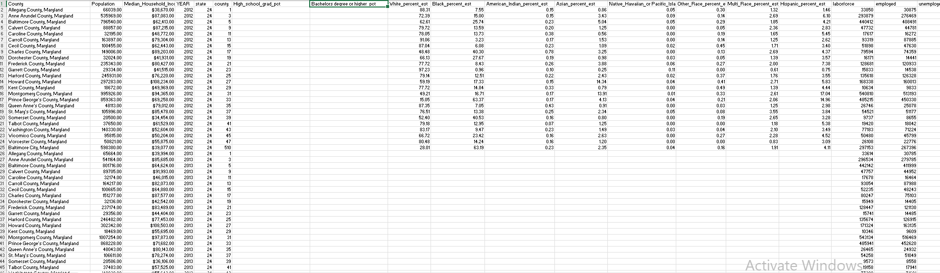

Testing for Normality
When data follows a distribution pattern, it is safe to rely on the mean as a comparison measure; however, if the data deviates from normality, misusing the mean can result in misinterpretation, making it crucial to conduct normality testing.
The distribution of crime rates and unemployment figures across counties tends to skew towards the side, with a few outliers representing regions with significantly high or low values. Median household income levels and attainment exhibit some slight. Generally, they follow normal distributions that vary between counties based on racial demographics. 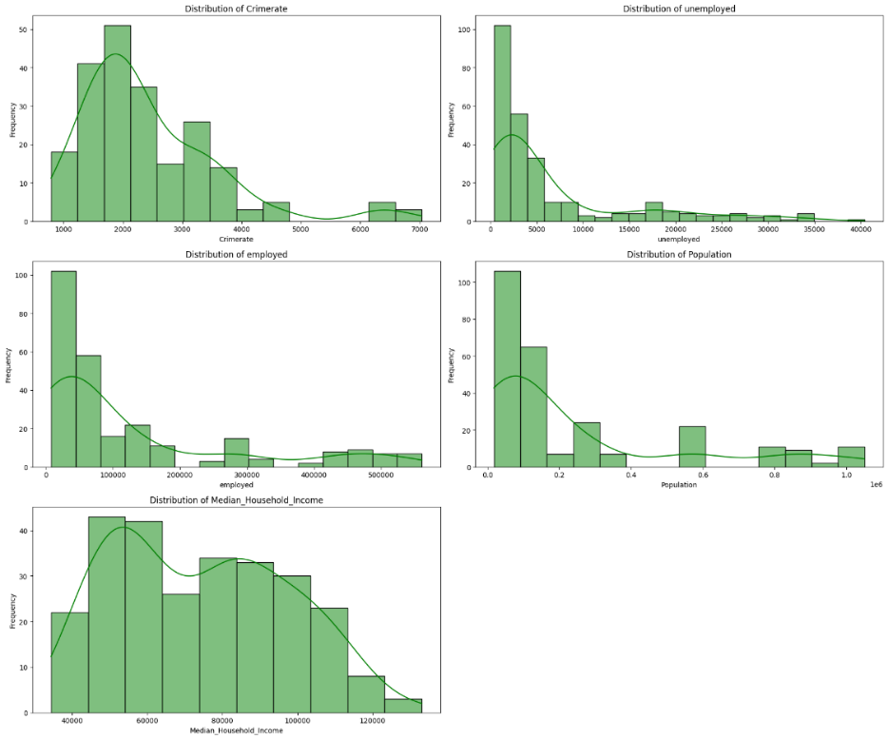

Data Transformation
This study used log transformations on measures like household income, crime rate, unemployment numbers, and employment figures to deal with the imbalance in how variables are distributed and opted for root transformations for the factors that stand independently. The goal is to tackle the tendency for skewness and create a balanced set of variables that work well for regression analysis. The advantages of utilizing log and square root transformations include diminishing the impact of outliers, boosting the normality of the data, and strengthening the reliability of models. The root transformation on variables like White, Black, High school, Bachelor, Asian, Hispanic, Native Hawaiian, and Other Races is more suitable for handling percentage values and does not heavily restrict values as much as log transformation. After making these adjustments, alignment between the independent variables was observed.
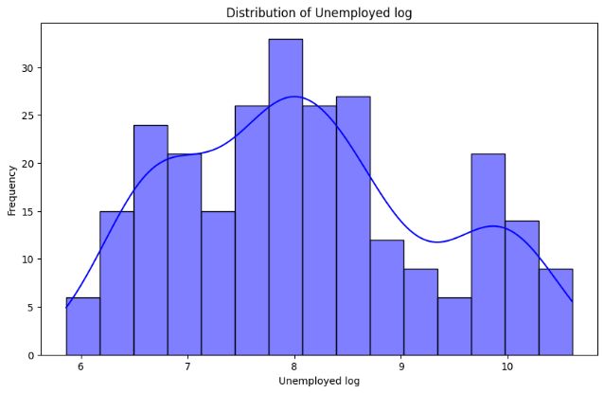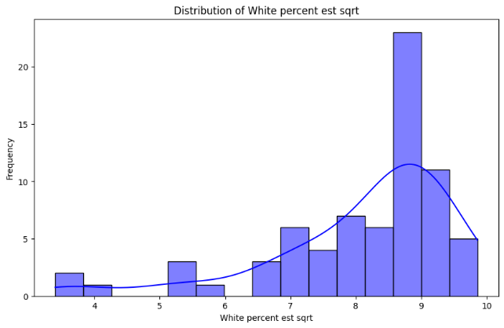
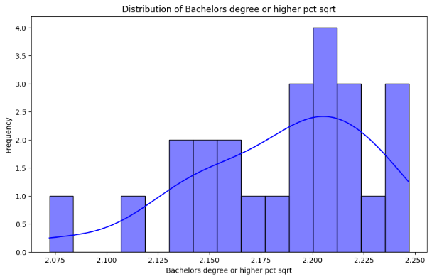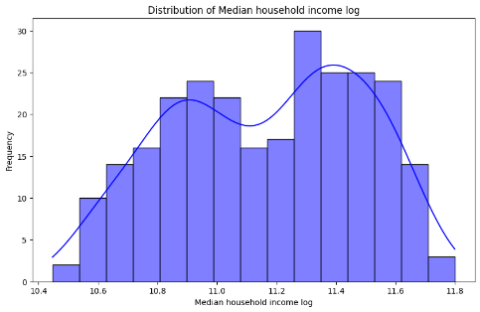
The use of log transformations on factors like Median household income and crime rate has helped make their distributions more balanced and less skewed for the analysis of assumptions of normality. These transformations have made distributions for crime rate and unemployment more consistent, even while making employment data more consistent. Furthermore, applying log transformations to White and Black Percent Estimates has emphasized differences in percentage ranges, making lower values more noticeable. The changes implemented have enhanced the uniformity of the data and boosted the strength of our analysis.
Analyzing Data Statistics and Visualizing Information
The dataset consists of 264 observations for most variables, with a few variables (racial demographics) having only 72 observations. The key findings are:
Crime Rate (log): Mean of 7.70 with a standard deviation (Std) of 0.44, indicating moderate variation. The crime rate ranges from 6.67 to 8.86.
Population (log): Mean of 11.71 and Std of 1.21, ranging from 9.79 to 13.86, indicating significant population variation across counties.
Unemployment (log): The mean is 8.09, and the standard deviation is 1.19. Values range from 5.86 to 10.61, showing wide variation in unemployment.
Employment: Mean of 126,394, with considerable variation (Std of 153,331), ranging from 8,040 to 560,710.
Median Household Income (log): Mean of 11.17, showing moderate variation ranging from 10.45 to 11.80.
Racial Demographics: The percentage estimates for White, Black, Asian, and other races display significant variability across counties, with White and Black populations being the most prominent groups on average.

Analyzing Multicollinearity
The correlation matrix was essential in our analysis as it looked at the connections between factors like unemployment rate, level of education, income level, and population size with the crime rate. This matrix helped us determine which factors were strongly linked to crime rates. Moreover, it showed that some of our predictor variables were related. Considering them together in the model could result in biased errors. This would cause fluctuations in p values when evaluating predictor significance. This could lead to interpretations that are invalid and impractical in real-world scenarios. The heatmap in Figure () visually illustrates how variables are related and highlights multicollinearity among them.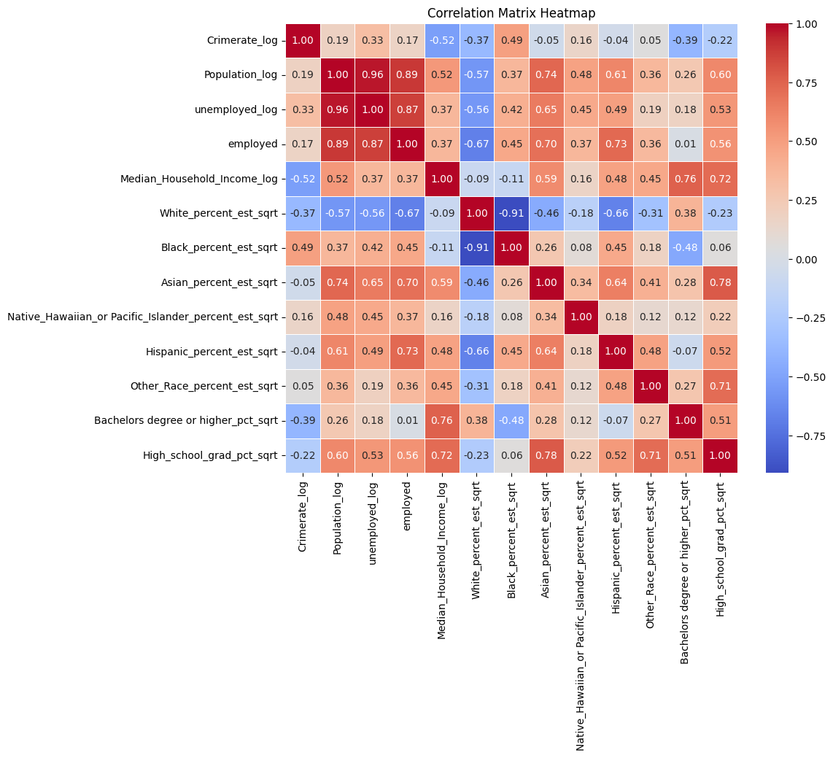
The model coefficients reveal critical relationships between variables and crime rates: unemployment shows a moderate positive correlation (0.33) with crime, indicating higher unemployment is linked to increased crime rates. Education, measured by high school graduation (-0.22) and bachelor’s degree attainment (-0.57), has a moderate to strong negative correlation, suggesting higher education is associated with lower crime rates. Median household income also has a slight negative correlation (-0.52) with crime, implying that higher income reduces crime. Population shows a weak positive correlation (0.19), indicating larger populations are mildly associated with higher crime rates. These results highlight the influence of socioeconomic factors on crime.

Addressing Multicollinearity
Methodical examination techniques like the variance inflation factor (VIF) are used to check for multicollinearity in our analysis. Correlation coefficients are used to address this issue comprehensively in the research paper. Under consideration, we relied heavily on the VIF metric to evaluate multicollinearity issues during our examination. Values exceeding ten are deemed significant multicollinearity since they may exhibit strong correlations with other variables, leading to potential problems in the model by causing an overestimation of the standard errors associated with the coefficients. The statistical equation used for this assessment is as follows.
VIF=$\frac{1}{1-R_{i}^{2}}$
Where $R_{i}^{2}$ represents the unadjusted coefficient of determination for regression of the $i^{th}$independent variable on the remaining ones. If $R_{i}^{2}$Is equal to 0, the variance of the remaining independent variables cannot be predicted from the $i^{th}$independent variable.
Here is a summary of the findings:
High VIF values:
Const (47802.26): Exceptionally high, indicating severe multicollinearity. The intercept should be addressed.
Population_log (36.54) and Unemployed_log (26.18): Both have very high VIF values, indicating significant multicollinearity and should be considered for removal or transformation.
Moderate VIF values:
White_percent_est_sqrt (12.22) and Black_percent_est_sqrt (8.45): These variables also show substantial multicollinearity.
Employed (5.86) and Median_Household_Income_log (3.48): Moderate levels of multicollinearity.
Low VIF values:
Features such as Crimerate_log (2.04), Asian_percent_est_sqrt (2.29), and others have relatively low VIFs, indicating minimal multicollinearity.
This analysis suggests the model suffers from multicollinearity, particularly with variables like Population_log and Unemployed_log. Corrective actions like variable removal or transformation may be required to improve model reliability.
Correction of multicollinearity
Multicollinearity is present with some predictors exceeding a threshold of 10, which may lead to type II errors. One or more highly correlated variables will be removed, or techniques like Principal Component Analysis (PCA) or Partial Least Squares Regression (PLS) will be used to address this. The models were validated using the F-statistic to assess overall significance, the Durbin-Watson statistic to check for autocorrelation, and normality tests on residuals to ensure the model's reliability and robustness.
The Ordinary Least Squares (OLS) regression results suggest that the model explains 49.1% of the variance in the log-transformed crime rate (R² = 0.491), with an adjusted R² of 0.731. The model is statistically significant (F-statistic = 27.24, p < 0.001).
Employed_log (-0.1504): A 1% increase in employment decreases the log crime rate by 0.150 (p = 0.038).
Unemployed_log (0.3210): A 1% rise in unemployment increases the log crime rate by 0.321 (p < 0.001).
Median Household Income_log (-0.7124): A 1% increase in income reduces the log crime rate by 0.712 (p < 0.001).
Other_Race_percent_est_sqrt (0.4988): A higher percentage of "other races" correlates with increased crime (p = 0.007).
Other variables including race and education, were not statistically significant. The model diagnostics show slight positive autocorrelation (Durbin-Watson = 1.443). Residuals are nearly customarily distributed (Kurtosis = 2.838), but multicollinearity is a concern (Condition Number 4330). This indicates that some variables may be highly correlated, which could affect the reliability of estimates. 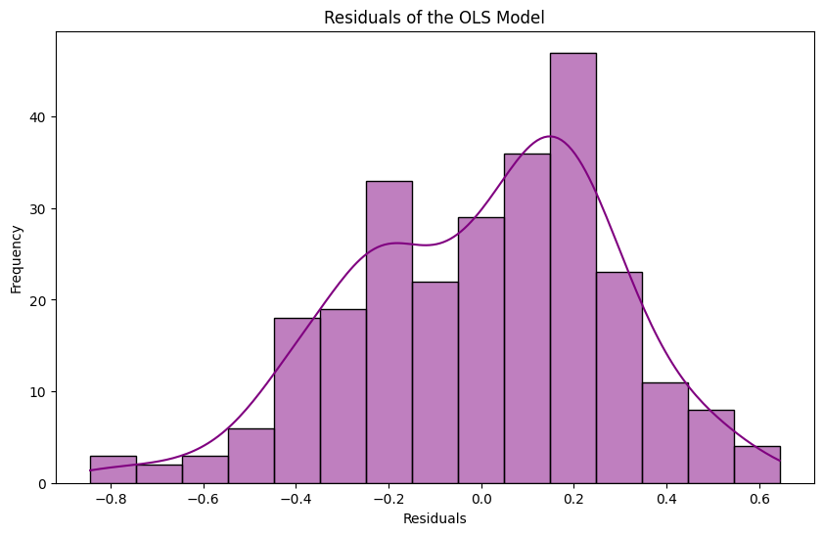
Assessing The Model’s Predictive Accuracy
The OLS (Ordinary Least Squares) regression model was validated using an 80/20 train-test split to ensure accurate predictions. The model's performance was evaluated on the test data using Mean Squared Error (MSE), Root Mean Squared Error (RMSE), and R-squared.
MSE: 0.092, indicating a relatively small average squared error between the predicted and actual log-transformed crime rates.
RMSE: 0.303, meaning the model's predictions, on average, deviate by 0.303 units.
R-squared: 0.477, suggesting the model explains 47.7% of the variation in crime rates in the test data.
While the model shows moderate predictive accuracy, 52.3% of the crime rate variation remains unexplained, indicating the potential influence of other unmeasured factors.

Correlation between Median household income and crime rates

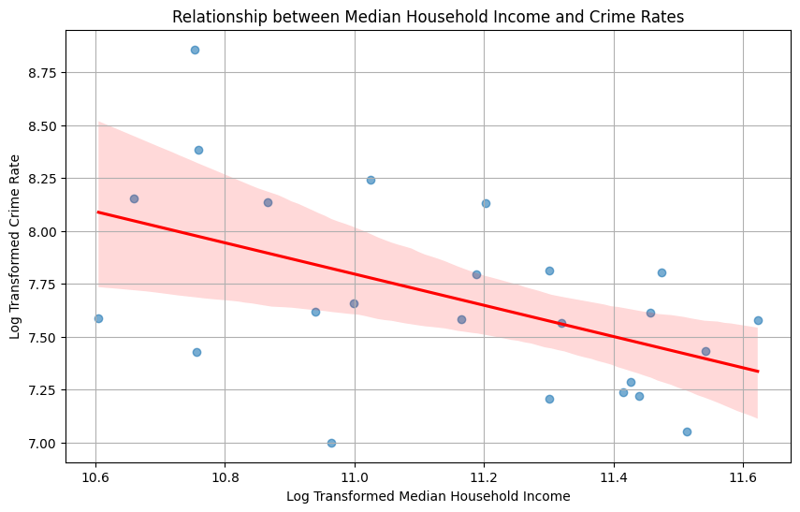
This analysis shows a negative relationship between income and crime, with higher income levels generally associated with lower crime rates. A linear regression line indicates that crime rates decrease as median household income increases. Each blue dot represents an observation of likely different counties, while the shaded confidence interval (likely 95%) shows where the actual regression line is expected to fall. The confidence interval is wider at lower income levels, indicating more variability, and narrows as income increases, suggesting the relationship between income and crime is more stable in wealthier counties. The plot shows a moderate negative correlation between income and crime rates.

Is higher unemployment a significant predictor of higher crime rates?
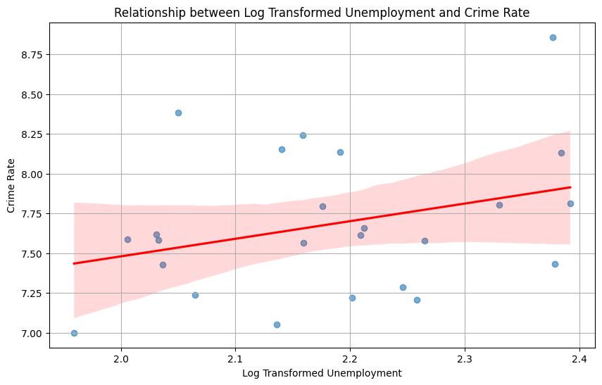
The regression line is slightly upward-sloping, indicating a positive relationship. The crime rate increases as unemployment increases (even after log transformation). The shaded area suggests a weak positive correlation between long-transformed unemployment and crime rates, as evidenced by the slight upward slope of the red line; this means that higher unemployment is associated with slightly higher crime rates.
Is a higher population of white associated with a higher crime rate?

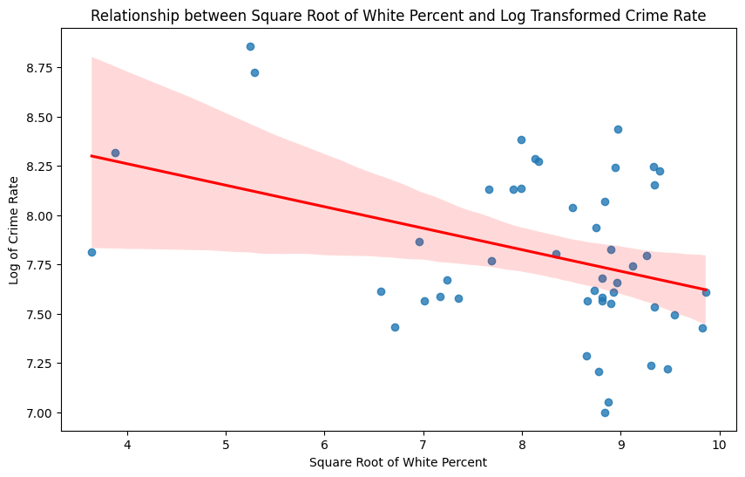
This scatter plot with a regression line shows each observation in the dataset compared in terms of the square root of White Percent and the log-transformed crime rate. It indicates a negative correlation between the square root of White Percent and the log-transformed crime rate. In other words, as the square root of White Percent increases, the log of the crime rate tends to decrease slightly. This is a weak negative relationship between the White population and crime rate, meaning areas with a higher White Percent tend to have slightly lower crime rate.
Model fitting
Previously defined ‘y’ as the dependent variable and x1,x2, and x3 as the ‘k’ independent variables. The multiple regression model, hence, will have a normal distribution defined as
Y = $β_{0}+β_{1}X_{1}+β_{2}X_{2}+β_{3}X_{3}+β_{4}X_{4}+є$
Where,
Y= Crime rate
$β_{0}$ = y-intercept
$β_{1}$ = is the slope of y with Unemployment, holding the remaining variables, Median Household Income, High School graduation, and White percentage, constant.
$β_{2}$= Is the slope of y with Median Household Income holding the remaining predictors constant?
$β_{3}$ = is the slope of the crime rate with the White population percentage holding the remaining predictors as constant
E = is the error term.
Crime rate = 16.3833 + 0.2292 * Unemployed + (-1.0443) *Median Household Income + (-0.1757) * Highschool graduation percentage + (-0.0334) * White Population percentage.

The way to interpret this model is as follows:
Each additional one-unit increase in the Unemployment rate is associated with an average increase of (0.2292), assuming all other predictors are constant. This positive coefficient indicates a direct relationship between the unemployment rate and the dependent variable.

Standard Error Result
A minor standard error indicates that the coefficient is estimated with higher precision, suggesting that it is closer to the "true" value in the population. This one will be used to calculate the t-statistic for hypothesis testing.
Constant (15.3833): Statistically significant with a p-value of 0.000, serving as the baseline for the model.
Median Household Income (log): A 1% increase in median household income is associated with a 1.0443% decrease in the crime rate (highly significant, p = 0.000).
Unemployment (log): A 1% increase in unemployment is associated with a 0.2292% increase in the crime rate (highly significant, p = 0.000).
Bachelor's Degree Percentage (sqrt): The coefficient is 1.1781 but not statistically significant (p = 0.483).
High School Graduation Percentage (sqrt): The coefficient is -0.1757 but not statistically significant (p = 0.546).
White Population Percentage (sqrt): The coefficient is -0.0334 but not statistically significant (p = 0.295).
Income and unemployment are significant predictors of crime rate, while education and racial variables are not statistically significant in this model.
Performing hypothesis testing
To validate the model, a hypothesis test was formulated to determine whether there is a genuine relationship between the crime rate and median household income or if the results obtained are merely due to chance.
Let us define the hypothesis for the model.
$H_{0}$= There is no relationship between crime and median household income ($β_{1}$=0)
$H_{1}$= There is a relationship between crime and median household income ($β_{1}$ ≠ 0)
Need to determine$β_{1}$is sufficiently far from zero that one can be confident that $β_{1}$Is non-zero with the calculated SE.
For this, the t statistic has been used
Using the formula.
$\frac{β_{1}}{SE(β_{1})}$
Where
$β_{1}$ is the estimated coefficient of Median household income (-1.0443)
SE is the standard error of the estimated coefficient (0.066)
t-statistic = -1.0443/0.066
t-statistic = -15.818
Indicates that the coefficient is highly statistically significant.
Strong evidence suggests that Median_Household_Income_log has a significant negative linear relationship with the dependent variable in the model. The null hypothesis ($H_{0}$​) was rejected.

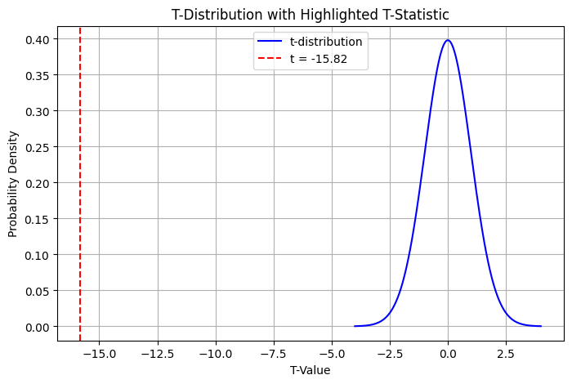

RESULTS
The study results offer insights into how social and economic factors influence crime rates in Maryland with a focus on employment and unemployment levels' impact on activities, an inverse relationship between job opportunities and crime rates, and a direct one between unemployment and increased crime rates are emphasized The research also emphasizes the crucial role of median household income in lowering crime rates by showing that counties, with higher income, tend to have lower crime levels. Moreover,​ the study highlights the significance of achieving an education​, indicating that lower crime rates are linked to levels of education​. While there is a correlation between makeup and crime rates,​ economic factors have a more significant impact in this regard​. By applying validation methods like VIF,​ the research findings gain credibility​. ​ The outcomes emphasize how economic stability and educational achievement shape Maryland's crime rates​.

CONCLUSION
The research offers knowledge about how socioeconomic factors are linked to crime rates in Maryland. It reveals connections between unemployment rates, educational attainment, income levels, and crime rates, with education being crucial. A predictive model has been created that explains around half of the variations in crime rates, underscoring the nature of forecasting crimes. The study indicates that higher education and income levels tend to be linked with crime rates, whereas higher unemployment rates are associated with increased activities. The study also suggests delving into disparities linked to racial demographics. You should consider these results when shaping policies and strategies to prevent crime effectively by focusing on education investment and addressing inequalities with an approach to crime prevention.
This research offers insights urging a look at other factors impacting crime rates. Future investigations could enhance their understanding of crime dynamics by including variables and statistical methods. In the end, this research lays down a foundation for making policies in Maryland that are backed by evidence and aimed at preventing crime and fostering community growth.

REFERENCES
Brush, J. (2007). Does income inequality lead to more crime? A comparison of cross-sectional and time-series analyses of United States counties. Economics Letters, 96(2), 264–268. https://doi.org/10.1016/j.econlet.2007.01.012
Bayoumi, S., AlDakhil, S., AlNakhilan, E., Al Taleb, E., & AlShabib, H. (2018). A review of crime analysis and visualization. Case study: Maryland state, USA. In 2018 International Conference on Innovations in Information Technology (IIT) (pp. 104-108). IEEE.
Britt, C. L. (1997). Reconsidering the unemployment and crime relationship: Variation by age group and historical period. Journal of Quantitative Criminology, 13(4), 405-427.
Canter, P. R. (1999). Geographic information systems and crime analysis in Baltimore County, Maryland. In Crime Mapping and Crime Prevention (pp. 157-190). Criminal Justice Press.
Coccia, M. (2018). Economic inequality can generate unhappiness that leads to violent crime in society. International Journal of Happiness and Development, 4(1), 1-24.
De Nadai, M., et al. (2020). Socio-economic, built environment, and mobility conditions associated with crime: A study of multiple cities. Scientific Reports, 10(1). https://doi.org/10.1038/s41598-020-70808-2
Groshen, E. L., Juhn, C., Orr, J. A., & Walter, B. L. (1999). Unequal incomes, unequal outcomes? Economic inequality and measures of well-being: Proceedings of a conference sponsored by the Federal Reserve Bank of New York. Economic Policy Review, 5(3).
Harries, K. (2006). Extreme spatial variations in crime density in Baltimore County, MD. Geoforum, 37(3), 404-416.
Interpret the key results for Display Descriptive Statistics - Minitab. (n.d.). (C) Minitab, LLC. All Rights Reserved. 2024. https://support.minitab.com/en-us/minitab/help-and-how-to/statistics/basic-statistics/how-to/display-descriptive-statistics/interpret-the-results/key-results/
Kiernan, D. (n.d.). Chapter 1: Descriptive Statistics and the Normal Distribution | Natural Resources Biometrics. https://courses.lumenlearning.com/suny-natural-resources-biometrics/chapter/chapter-1-descriptive-statistics-and-the-normal-distribution/
Lochner, L., & Moretti, E. (2004). The effect of education on crime: Evidence from prison inmates, arrests, and self-reports. American Economic Review, 94(1), 155-189.
Medium. (n.d.). Medium. https://machine-learning-made-simple.medium.com/why-you-should-analyze-the-distribution-of-your-data-695fd9f0f1be)
Raphael, S., & Winter-Ebmer, R. (1998). Identifying the effect of unemployment on crime. University of California, San Diego, Department of Economics, 98(19).
Roth-Johnson, L., PhD. (2017, February 12). Introduction to descriptive statistics. Vision learning. https://www.visionlearning.com/en/library/Scientists-and-Research/58/Introduction-to-Descriptive-Statistics/218/reading
South, S. J., & Messner, S. F. (2000). Crime and demography: Multiple linkages, reciprocal relations. Annual Review of Sociology, 26, 83-106.

